Name ________________________

Engineering with Simple Machines
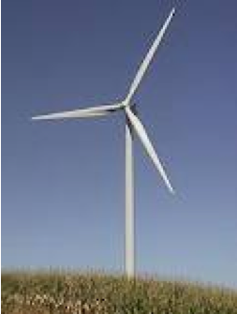
Wind Turbine
In science class, students learn scientific theories about the world we live in. But how does scientific knowledge become the technology that we use every day? Often, engineers do this work. Just as scientists study science, engineers practice engineering: the art of applying scientific, mathematical, and practical knowledge to the creation of buildings, machines, vehicles, and many other goods.

One type of engineering is mechanical engineering. Mechanical engineers work with any type of technology that can change energy from one form to another. For example, mechanical engineers help design the engines that convert chemical energy (stored in gasoline) to the kinetic energy of a moving car. Another example is a wind turbine, which converts kinetic energy in wind to electrical energy.

A scientific concept that you may be familiar with related to mechanical engineering is the simple machine. Energy is used to do work, so mechanical engineers use machines to change how that work is done. They can either make work easier, by reducing the force needed, or make work faster, by increasing the distance traveled.

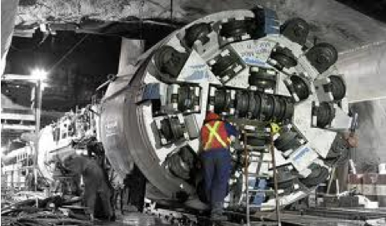Many mechanical engineers use simple machines in the products that they work on. For example, there are many gears in an automobile transmission or in the wind turbine mentioned above. Wedges are used to create metal cutting machines and sorting machines in assembly lines. Screws appear in tunnel drilling equipment and harvester combines.
Tunnel Drilling Machine

The simple machine that we will focus on is the lever, and we will see how engineers can also take ideas from nature to make new things. Both walking animals and walking robots may use levers to amplify muscle motion. We will explore how this can be done and experiment with our own walking robots, as we learn more about what engineers do.
Questions:

1. What do engineers do with scientific knowledge?

2. Give an example from the reading of a product that an engineer might work on:

3. Give an example of a product that you think an engineer might work on, that wasn't in the reading:

4. Give an example of a simple machine:

5. Give an example of a simple machine used in a product designed by an engineer:

When you have finished the above questions, go to the microscope to look at the robotic bug, and answer the final two questions:

1. How is the robot bug similar to a real insect?

2. How is the robot bug different from a real insect?

