Legendary Leg-bots

Objective: Introduce students to trade-offs involved in use of simple machines and in engineering design through construction of legs for walking motorized robots.
Prep Time: 15 minutes per motor and chassis; possibly substantial time to acquire Lego components (see notes)
Lesson Time: 50-120 minutes
Personnel Needs: 1-2 helpers recommended for robot testing, in addition to instructor.
Materials:
- Hobby Motors (make)
- Alligator clips
- 4-12 AA batteries
- Holder (with wires) for 4 AA batteries
- Lego robot chassis (see parts list and instructions in Appendix)

Topics: Simple machines (levers); Engineering design; Forces; Electric motors.

Grade Level: 7-8

Notes and Themes: This project was tailored to fit the Ypsilanti Middle School 8th grade science curriculum, and as such is closely tied to previous activities in that class. In a more general setting, the most usable aspect is probably the Lego-based robot design that produces walking motion from true level mechanisms at each leg. As originally performed, this project followed a month-long unit on simple machines and a week of experiments related to bio-inspired design and biomimicry. Thus, the dual themes for robot design were that engineers often draw inspiration from nature and that engineers must make trade-offs when designing products. For example, a lever cannot move both a long distance and produce a large force, given the same inputs. Also included in the unit as implemented, between an introductory reading (included in project materials) and robot construction, was a series of student experiments with lever models from different sources (the skeleton, construction machinery, pliers and scissors) that were cut from cardboard and loaded with various weights to observe their behavior. This was used to further emphasize that levers that were moved long distances supported less weight, and vice versa.
Regarding setup, there is a fair bit of initial overhead time to order the Lego parts required and construct the base motor units (though this construction is quite fast once the first motor has been built and one knows how it is done). The robot chassis and motor assembly is also designed to come apart if excessive force is applied to the legs (the Lego Technic disk “cam” piece will detach from the driving gear axle), and thus it can be useful to have extra help in the classroom to help with emergency repairs and keep students’ construction going.

Pre-requisites:
Simple machines:
- Know that machines can make work “easier” (use less force) or make work “faster” (move a greater distance or in a different direction).

Forces and motion:
- Know that a force is a push or pull on an object
- Know that speed is distance divided by time

Materials

(Per robot)
1 Hobby Motor (Gear reduction necessary; recommended motor: Tamiya 3-Speed Crank Axle Gearbox; at the time of writing, available inexpensively at www.hobbyengineering.com when buying more than 4)
Robot Body Parts (See Lego inventory list)
¼” washer
Rubber bands

(For assembly)
Metal shears
Epoxy (Recommended: Evercoat 108017 Epoxy 2-Part Glue Syringe or similar 2-part epoxy in syringes)

(Per classroom)
8-12 AA Batteries
2-3 Battery holders for 4 AA batteries, with wire leads
4-6 Alligator clips

(Optional – see below)
Obstacle course: for robot agility –sheet of cardboard with obstacles taped or glued in place
Ramp: for robot strength – two rulers at an incline for that balls of various weights (wiffle, tennis, etc.) can be pushed up
Race course: for robot speed – flat surface marked with distances from starting point

Sample robots and robot testing courses (left: obstacles, right: weight on ramp)

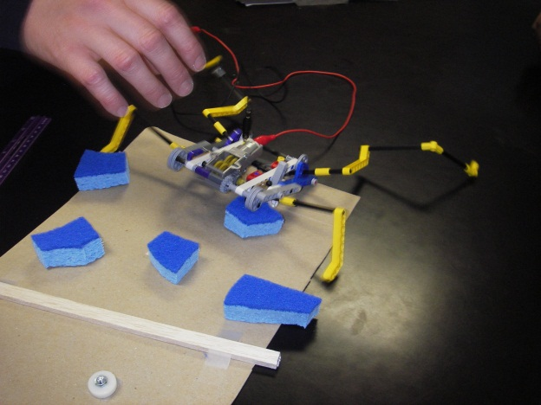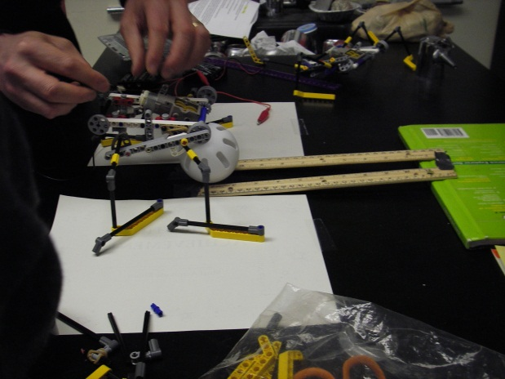

Lesson Plan Summary:
Preparation for the lesson:
- Order materials: since this project makes use of a specific type of motor and set of construction blocks (Lego) some planning will likely be required to obtain the materials ahead of time. A good resource for specific Lego parts is www.brickbay.com, where individual components may be found. 10 robots worth of parts cost ~$100, from 4-5 resellers for the correct assortment as of May 2012. The hobby motors used are Tamiya 3-Speed Crank Axle Gearboxes, available on many hobby websites.
- Unless the students will build the motors robot chasses themselves (suitable for advanced students), motors then chasses must be assembled ahead of time. Allow about 30 minutes for the first motor and chassis and 5 minutes for each additional robot body. Instructions for motor and chassis construction are included in the Appendix to this document.
- Sort extra parts for robot leg construction into bags for each team.
- Optionally, prepare testing tracks for the robots, such as an inclined plane (we used two rulers supported by books, with a ball set between the rulers), obstacle course (various leftover materials glued/taped to a cardboard sheet), race track (cardboard panel with distances marked).

Lesson (basic routine, very open-ended):
- Introduce goal of laboratory: build a walking robot. Demonstrating a working robot is recommended. Make clear that students will be designing the robot legs and show where legs will attach. If applicable, remind students of what they have learned about simple machines, engineers, and/or biomimicry, particularly need for engineers to make decisions about trade-offs between, say, levers (legs) that can move a long way and levers that can push large forces.
- Have students form groups of 2-4, based on number of robot chasses available and size of class.
- Pass out Design Worksheets and instruct students to talk with their group about what goals they have for their robot.
- Pass out robot bodies and bags of parts for legs, and let students build robot legs. After about 10 minutes, offer to start testing robots with battery pack and alligator clips. Having 1-2 helpers for testing can be very useful at this point.
- If performing experiments over multiple days, instruct students to make a sketch of their leg design about 5 minutes before breaks. This can be used to emphasize the importance of visual communication, in addition to a way to remember designs if legs are disassembled for other students to use.
- If performing experiments over multiple days and other groups will use the robots in between sessions, have students remove the legs from the robot bodies and return their parts to bags before they leave.
- If done as implemented in the Ypsilanti School District, the post-test was performed before passing out robot materials in the second day of construction and testing. The post-test requires about 10 minutes to complete in its original form.
- Pass out robot materials to groups as their members complete the Post-Test. Remind students that they should aim to test their robot out on at least one of the “courses” if present (i.e. speed, weight, obstacles) to remind them that they should have a goal as they finalize their robot design.
- After 10-20 minutes to complete their final robots, begin testing robots for aforementioned quantities (speed, weight pushed, ability to traverse obstacles, or any other test of your choosing). Record to
- Remind students to complete their reflections on their design worksheets and turn in the design worksheets before leaving.
- With 5-10 minutes remaining, have students do a final disassembly of their leg pieces and return the parts to the bags as they received them.

